Cashdata release 2009.1.0 Patch 1 is to be applied only to Cashdata 2009 Release (for all licence types including Cashdata 2009 D.I.Y. Superannuation edition). This patch corrects the audited operating statement for handisoft format superannuation reports for years 2006 to 2008 and adds rental property income and expense sub accounts int the master chat of accounts for properties 5 to 10. The latter are needed where Industrial Property is held in a superannuation fund, or overseas real estate in the case of sub-code 10.
FILES TO DOWNLOAD
There is only one file to download.
DOWNLOAD INSTRUCTIONS
- Print this page for reference.
- Left mouse click on the 'download' icon to the left of this screen
- Select “Save this file to Disk “ (or similar) and then select an appropriate directory to store the software eg C:\Downloads
INSTALLATION INSTRUCTIONS
- All Cashdata sessions on your standalone PC, Workgroup and or Network should be closed (exited).
- If the patch is to be installed onto a Network - it is only necessary to install the patch on the computer that has the license file e.g. the server or primary workstation. This can be located by menu items File | Cashdata Setup | Startup.
- Using Windows Explorer locate the file “Cashdata2009.1patch1.exe” in your downloads folder eg. “C:\Downloads” (or other folder created in “Download Instructions” Download step 3 above) and with your mouse, double click on this self extracting file.
- Winzip self extractor will launch and display in the “Unzip to folder” “C:\Program Files\Practitioner Technologies\Cashdata\M_Detail”. This is the default location of Cashdata reports for a stand alone system. If this is correct proceed with the extraction.
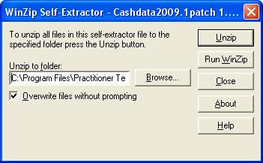
- Note if you have upgraded from an earlier version of Cashdata the default location will need changing in this updater (former versions location was “C:\Program Files\Cashdata\M_Detail”. If the folder location otherwise requires changing e.g. because of a non-standard installation folder or it is to update a server installation it will be necessary to key the correct path in the “unzip to folder” section of the extractor. To locate the path launch Cashdata and follow the menu. File | Cashdata Setup | Startup. In the server example below the license path is shown as P:\Cashdata.
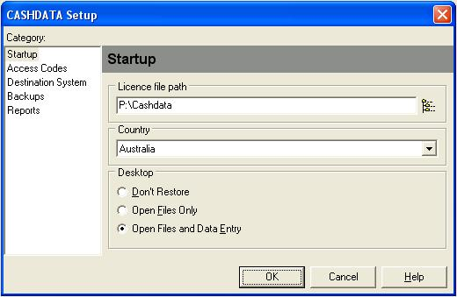

- Either key the path into the “Unzip to folder” in the Winzip extractor e.g. “P:\Cashdata\M_Detail” for the above example or use the browse button in the Winzip extractor to locate the license file path then the M_Detail subfolder. The correct path will appear without the need to key, by using the browse button. After the correct path appears in the “Unzip to Folder” section of the extractor, proceed with the extraction. Olds files will be overwritten.
INSTALLATION CHECK
- Create a new test Superannuation fund in Handisoft format for the 2008 year and check the chart of accounts.
- If account “1798 Management fees” is in the chart of accounts the patch has been successful

